An Experimental Study to Detect the vocal cyst using YOLO

MOHAMMED MUJEEB KALADGI

A thesis submitted in partial fulfilment of the requirements of Liverpool John Moores University for the degree of Master of Science in Machine Learning & Artificial Intelligence

November 2020

# DEDICATION

I dedicate this work to my family, which thought me the value of a good education. Special thanks to my wife Ashrin Nida, she motivates me to be a better person every day. I am in awe watching her balance looking after our family, her professional life and her academics.

Thanks to my parents Hazarat Ali Kaladgi and Mumtaz Begum, who sacrificed a much better economic life for themselves. Instead ensured their children got a good education.

Thanks to my daughter Inaaya, and my nieces and nephews Kashf, Khushi, Hiba, Kashish, Sara, Owais, Aliya, Hamza and Omar, who are the life of our family.

# ACKNOWLEDGEMENT

I would like to thank the following people, without whom I would not have been able to complete this thesis.

I express my deepest thanks to Dr Manoj Jayabalan, whose insight and knowledge into the subject matter steered me through this research. I acknowledge his contribution gratefully.

Thanks to my student mentor Saheb Chhabra for his guidance and sharing his expertise. Thanks to my friends in my cohort for being the most selfless guides one can be.

Thanks to my technical assistant Rashmi S for helping me at various stage.

# ABSTRACT

Deep learning algorithms have quickly become tools of choice for analysing medical images. Various deep learning methods, like object detection, image classification, segmentation, registration, and other tasks are used in the medical field. The convolutional neural network (CNN) is a type of deep learning neural networks which are commonly used for image classification and object detection.

The vocal cords sometimes referred to as vocal folds are two plates of muscle tissue located inside the larynx. The muscle tissue vibrate, while air passes through the muscle tissue originating from the lungs to produce the sound of your voice. Image 1 shows the vocal cords in the larynx (Online, 2020).

Image not required

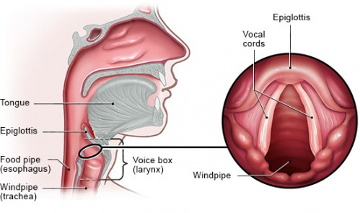

Fig. 1:Voice Generating Organs and Vocal cords (NIDCD, 2020)

Vocal cord cysts is an abnormality in the vocal cords. Vocal cord cysts are diagnosed using Laryngoscopy. During a Laryngoscopy, a scope is pushed into the patient's nose until it reaches close to the vocal cords. Surgery may be required to treat vocal fold cysts(NIDCD, 2020).

General physicians often misidentify a vocal cord nodule to a vocal cord cyst and vice versa. Vocal cord nodules are treated using voice therapy while a vocal cord cyst is treated by a microsurgery. After prolonged suffering because of misidentification, the general physician refers the patient to a Laryngologist. Additionally there is not enough study done in automated real-time identification of vocal cord cyst in a Laryngoscopy video.

This research aims to develop a model to detect vocal cord cyst in a Laryngoscopy video in real-time, to assist the general physician/laryngologist/scope operator. It is move toward reducing dependence on an expert laryngologist, produce consistent results irrespective of the doctor's experience and make the Laryngoscopy procedure affordable.

The study proposes a dataset of Laryngoscopy videos. The dataset is transformed, labelled, trained and analysed. The study uses YOLO version 3 object detection algorithm for vocal cord cyst detection and Labelimg for manually labelling frames of the Laryngoscopy videos.

This research will reduce the time taken for Laryngoscopy procedure, assist doctors, produce consistent results and make the procedure affordable.

Result of this study was real-time detection of vocal cord and vocal cord cyst as shown in the figure<Number>. The average confidence level of vocal cord detection was 0.82, and that of vocal cord cyst was

# LIST OF FIGURES

Fig. 1:Voice Generating Organs and Vocal cords (Care, 2020) 10

Fig. 2: Vocal Cord Cyst 12

Fig. 3: Voice Organs, Vocal Cord vibrating and Vocal cord open 20

Fig. 4: Epiglotis 21

Fig. 5: Larynx 21

Fig. 6: Larynx Anatomy 22

Fig. 7: Larynx and Vocal Cords 23

Fig. 8: Vocal Cord Opened 23

Fig. 9: Vocal Cord CLosed 24

Fig. 10: Observed Occurrances 25

Fig. 11: Vocal Cord with Laryngitis 26

Fig. 12: Vocal Cord Nodule 27

Fig. 13: Vocal Cord Nodule 27

Fig. 14: Vocal Cord Paralysis 28

Fig. 15: Vocal Cord Paralysis 29

Fig. 16: Laryngeal Papilloma 29

Fig. 17: Vocal Cord Cyst 30

Fig. 18: Vocal Cord Cyst 31

Fig. 19: Indirect Laryngoscopy 32

Fig. 20: Direct Laryngoscopy 33

Fig. 21: Flexible Fiberoptic Laryngoscopy 33

Fig. 22: Laryngoscopy procedure 34

Fig. 23: Mucosal cordotomy with sickle knife. 35

Fig. 24: Dissection between the epithelial cover and the cyst 36

Fig. 25: Dissection of plane deep to the vocal fold cyst, adjacent to the vocal ligament 36

Fig. 26: Dissection of plane deep to the vocal fold cyst, adjacent to the vocal ligament 36

Fig. 27: Redraping of microflap 37

Fig. 28:YOLO Architecture (online, 2020) 43

Fig. 29: Expected Outcome 44

Contents

DEDICATION 2

ACKNOWLEDGEMENT 3

LIST OF FIGURES 4

LIST OF ABBREVATIONS 6

ABSTRACT 10

CHAPTER 1: INTRODUCTION 12

1.1 Background 13

1.1.1 Background of the study 13

1.1.2 Relevance to previous research 13

1.1.3 Problem(s) 13

1.1.4 Purpose of the study 14

1.2 Related Research 14

1.3 Aim and Objectives 16

1.4 Research Questions 16

1.5 Scope of the Study 17

1.6 Significance of the Study 17

1.7 Structure of the Study 17

CHAPTER 2: LITERATURE REVIEW 19

2.1 Introduction 19

2.2 Background 19

2.3 Larynx 21

2.4 Vocal Folds/Vocal Cords 22

2.5 Vocal Disturbances 24

2.6 Treatment 32

2.6.1 Indirect Laryngoscopy 32

2.6.2 Direct Laryngoscopy 32

2.6.3 Flexible Fiberoptic Laryngoscopy 33

2.6.4 The Flexible Fiberoptic Laryngoscopy Procedure 34

2.6.5 Phonomicrosurgery 34

2.8 Object detection 37

2.8.1 YOLO 38

2.9 Summary 39

CHAPTER 3: RESEARCH METHODOLOGY 40

3.1 Introduction 40

3.2 Background 40

3.3 Dataset Description 41

3.4 Data Pre-processing and transformation 41

3.5 Models 42

3.6 Evaluation Metrics 43

3.6.1 Accuracy 43

3.6.2 Precision 43

3.6.3 Recall 44

3.6.4 Specificity 44

3.7 Expected Outcomes 44

3.8 Requirements 45

3.9 Summary 45

REFERENCES 46

APPENDIX A: RESEARCH PLAN 49

APPENDIX B: RESEARCH PROPOSAL 50

APPENDIX C: ETHICS FORMS 51

# LIST OF ABBREVATIONS

ANN: Artificial Neural Network 13

COCO: Common Objects in Context 12

Convolutional Neural Network 8

CUDA: Compute Unified Device Architecture 53

DT: Decision Tree 13

ELM: Extreme Learning Model 43

ENT: Ear Nose and Tongue 31

FN: False Negative 51

FP: False Positive 51

FPS: Frames Per Second 13

GAN: Generative Adversarial Networks 43

GPU: Graphics Processing Units 12

HOG: Histogram of Oriented Gradient 41

k-NN: K- Nearest Neighbour 12

LSTM: Long Short Term Memory 43

NB: Naive Bayes 13

R-CNN: Regions with Convolutional Neural Networks 13

RF: Random Forest 12

R-FCN: Region-based Fully Convolutional Networks 41

RNN: Recur-rent Neural Network 43

RPN: Region Proposal Networks 45

SIFT: Scale-Invariant Feature Transform 41

SSD: Shot Multibox Detector 41

SVM: Support Vector Machine 12

TN: True Negative 51

TP: True Positive 51

YOLO: You Only Look Once 8

# CHAPTER 1: INTRODUCTION

## 1.1 Background

The larynx is an organ located towards the top of the neck. It helps in producing sound and breathing. Larynx can be seen by the medical professional using laryngoscopy. It provides valuable details to the doctor to give his prognosis vocal cord issues.

The larynx contains the vocal cords. The vocal cords sometimes referred to as vocal folds. Vocal cords are two semi elastic muscle tissue found inside the larynx. The muscle tissue vibrates, and air passes through the cords from the lungs. This causes the production of sound which is a person’s voice. Figure 1 shows the vocal cords in the larynx. The vocal cords are susceptible to several disorders. Some common ones are vocal cord cysts, vocal cord nodules, vocal cord paralysis, laryngitis, vocal polyps. (NIDCD, 2020)

Vocal cord cysts are soft masses on vocal cords. These cysts are sac-like structures that are usually of white or yellow in color. They occur on one side of the vocal cords usually near the middle of the band. Vocal cord cysts are additional growths on the vocal cords that have a cover around a fluid-filled or soft center. Figure 2 shows what a cyst on a vocal cord.

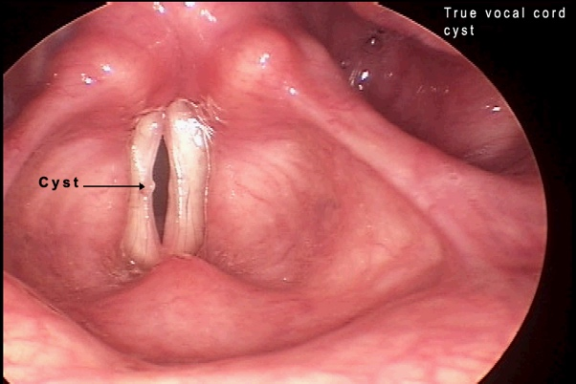

Fig. 2: Vocal Cord Cyst

The symptoms of vocal fold cysts are issues with the pitch of the voice and a hoarse voice(NIDCD, 2020). General physicians often misidentify a vocal cord nodule to a vocal cord cyst and vice versa. Vocal cord nodules are treated using voice therapy while a vocal cord cyst is treated by a microsurgery. After prolonged suffering because of misidentification, the general physician refers the patient to a Laryngologist. The Laryngologist is able to correctly diagnose the issue as a vocal cord cyst or a vocal cord nodule using Laryngoscopy.

During a Laryngoscopy, a scope is pushed into the patient's nose until it reaches close to the vocal cords. Surgery may be required to treat vocal fold cysts. Since the invention of video laryngoscopy some experts expect that it should be considered standard procedure. According to John Schweinfurth, the patients that visit a voice clinic are predominantly professional voice users.(NIDCD, 2020)

This research aims to develop an automated, real-time vocal cord cyst detection which will highlight the vocal cord cyst in the laryngoscopy video, thereby reducing cost. The study proposes a dataset of Laryngoscopy videos. The dataset is transformed, labelled, trained and analysed. The study uses YOLO version 3 object detection algorithm for vocal cord cyst detection and Labelimg for manually labelling frames of the Laryngoscopy videos.

This research will reduce the time taken for Laryngoscopy procedure, assist doctors, produce consistent results and make the procedure affordable.

### 1.1.1 Relevance to previous research

There is not enough research done on automated detection of vocal cord cyst in a laryngoscopy video. However the YOLO algorithm is used extensively for object detection. YOLO has been used to detect objects in medical domain.

Previous research has used YOLO version 1, 2 and 3 for object detection for different use cases. Overtime the performance of YOLO has improved. There is also another variation of YOLO called tiny YOLO that provides results faster with slight impact on the accuracy. In this research I will be using YOLOv3 and in particular using YOLOv3 to detect cyst in vocal cords. Prior researchers have either used different algorithm to detect cyst in vocal cord or have used YOLOv3 to detect other object (i.e. not vocal cord cyst)

### 1.1.2 Problem(s)

General physicians often misidentify a vocal cord nodule to a vocal cord cyst and vice versa. Vocal cord nodules are treated using voice therapy while a vocal cord cyst is treated by a microsurgery. After prolonged suffering because of misidentification, the general physician refers the patient to a Laryngologist. The Laryngologist is able to correctly diagnose the issue as a vocal cord cyst or a vocal cord nodule using Laryngoscopy.

The laryngologist usually takes 20 minutes to do the laryngoscopy and generate a report with his/her prognosis. This leads to the laryngoscopy procedure being expensive especially in countries like United States were medical expenses are high.

Expert laryngologist needs to have many years of experience to give correct and consistent prognosis.

### 1.1.3 Purpose of the study

The purpose of this research is to automate the detection of vocal cord cyst in real time. This will help the laryngologist or general physician during the procedure and reduce the time taken to complete the procedure. The research will also produce consistent results.

## 1.2 Related Research

### 1.2.1 Related research on Vocal Cord

https://www.ncbi.nlm.nih.gov/pmc/articles/PMC5960603/

The human larynx, a single sound generator, is capable of producing a voice of tremendous variety in pitch, intensity, and quality. In the 1970s Minoru Hirano set out to understand how singers can produce such variety in voice using only a single set of vocal folds. In 1974, Hirano published the cover-body theory of vocal fold vibration. Here he described the unique morphological structure of the vocal folds and divided them biomechanically into the body and the cover layer. The main substance of the vocal fold is the thyroarytenoid (TA) muscle. The TA, innervated by the recurrent laryngeal nerve, has mechanical properties that vary with activation. Overlying the TA is the elastic conus, or vocal ligament. This fibrous vocal ligament interdigitates with vocalis muscle fibers allowing the TA and vocal ligament to function as a single vibratory unit (body) during phonation. Superficial to the body lies the vocal fold epithelium and superficial layer of the lamina propria loosely associated with the vocal ligament. The superficial lamina propria and epithelium move as a vibratory unit (cover) weakly coupled to the body.

How is sound created

https://sci-hub.st/10.1038/scientificamerican0108-94

Ingo R. Titze writes the vocal folds (or vocal cords) in the larynx—has a complex, three-part structure that allows us to generate several octaves of frequencies. At the core of each fold is a stringlike ligament (cross section). Internal to the ligament are contractile muscles. And covering it all is a highly flexible mucous membrane. Each component brings a special capability to the whole. The ligament’s tensile stress rises rapidly with elongation (by muscles that move the cartilages attached to the folds), which helps to produce higher frequencies. The vocal-fold muscle can increase tensile stress as it contracts. In doing so, it generates an even larger frequency range. The soft, pliable surface of the outer membrane, which oscillates like a fl ag in the wind as air from the lungs passes over it, exchanges vibrational energy with the airstream to create sound waves.

### Related research on Vocal Cord Disorders

<https://books.google.co.in/books?hl=en&lr=&id=1RwVcsw0KLAC&oi=fnd&pg=PR1&dq=Colton+RH,+Casper+JK,+Leonard+R+(2011).+Understanding+Voice+Problems+(4th+ed.)&ots=eW_AWAF4PN&sig=ANYd7yd71CUGsbNIzEc8xgt9lcE#v=onepage&q&f=false>

Symptoms are

Hoarseness

Breathy voice Aphonia

Struggle with voice

Tremor

Vocal fatigue

Pain and other physical sensation

Aphonia

<https://doi.org/10.1016/j.otc.2007.05.008>

Vocal fold nodules (Fig. 3) are the end result of subepithelial scar deposition, primarily changing the mass and stiffness of the vocal fold cover, with little effect on the body

Vocal fold polyps, another form of subepithelial fibrosis and deposition, are histologically similar to vocal fold nodules, but differ in that they are unilateral

Vocal fold cysts present primarily with hoarseness, although diplophonia also may be a problem. Vocal fold cysts are present in the superficial lamina propria and can open into the laryngeal lumen or insert onto the vocal ligament

Vocal fold scar is a vexing diagnosis for patients and laryngologists. Although there is no agreement on how best to manage vocal fold scar, it is agreed that treatment outcomes are fair to good, but inconsistent at best

Varices Prominent or enlarged vessels within the vocal folds’ superficial lamina propria are variably termed microvascular lesions

Vocal fold hemorrhage is a laryngologic emergency that warrants immediate strict voice rest for 7 to 14 days and VLS to document the effects on the mucosal wave

Vocal cord nodules, Polyps and Cyst appear similar to an untrained eye. The below table by Michael M. Johns gives the differentiating characteristics of the three.

<https://sci-hub.st/10.1097/00020840-200312000-00009>

### Related research on Vocal Cord Cyst

https://www.ncbi.nlm.nih.gov/books/NBK535342/

Different type of cystic growths can happen inside the vocal cord and can possibly upset the normal voice creation.

Vocal cord cyst are subepithelial in root and can be either one-sided or occur on both the vocal cords.

These cysts are usually secondary to chronic irritation and may also cause reactive changes on the opposite fold. . Cysts can be either internal or external. Internal cysts lie within the thyroid cartilage and most often present with hoarseness. External cysts produce a laryngocele sac that protrudes the thyrohyoid membrane thus presenting with a compressible mass that will increase in size with increased pressure within the larynx.

<https://www.google.co.in/books/edition/Otorhinolaryngology_Head_and_Neck_Surger/l3fPEPZQqoQC?hl=en&gbpv=1&dq=Vocal+Cord+Cyst&pg=PA486&printsec=frontcover>

Cyst in the vocal cord are typically white, subepithelial, spherical, unilateral lesions located in the middle third of the vocal cords. Vocal cord cyst make up 5% of voice disorders. The cyst can be mutinous, serous or keratin. In case of a keratin cyst it is called an epidermoid cyst. It is usually attached to deep structures of the submucosa.

Vocal cord surgery is needed to remove the vocal cord cyst. Vocal misuse is often the reason that causes vocal cord cyst.

### Related research on Laryngoscopy

https://link.springer.com/chapter/10.1007/978-3-540-68107-6_17

Diagnosis of vocal fold cyst and vocal fold fibrous mass may be difficult preoperatively; however, videostroboscopy greatly improves the chances of detection. Often exploratory cordotomy is required to differentiate between the diagnoses of a fibrous mass versus vocal fold cyst.

<https://www.ncbi.nlm.nih.gov/books/NBK513224/>

A direct laryngoscopy allows visualization of the larynx. It is used during general anesthesia, surgical procedures around the larynx, and resuscitation. This tool is useful in multiple hospital settings, from the emergency department to the intensive care unit and the operating room. By visualizing the larynx, endotracheal intubation is facilitated.

### Related research on Microlaryngoscopy surgery

## [Kendig & Chernick's Disorders of the Respiratory Tract in Children (Eighth Edition)](https://www.sciencedirect.com/science/book/9781437719840)

<https://www.sciencedirect.com/science/article/pii/B9781437719840000693>

Microlaryngoscopy and rigid [bronchoscopy](https://www.sciencedirect.com/topics/medicine-and-dentistry/bronchoscopy) are performed with the primary goal of identifying anatomic levels of airway obstruction from the [larynx](https://www.sciencedirect.com/topics/medicine-and-dentistry/larynx) to the carina. The supraglottis is evaluated with attention given to the possibility of supraglottic obstruction such as [laryngomalacia](https://www.sciencedirect.com/topics/medicine-and-dentistry/laryngomalacia) and supraglottic stenosis.

https://link.springer.com/chapter/10.1007/978-3-540-68107-6_17

Delicate handling of the cyst is necessary to avoid rupture, which will complicate the removal.

■ Surgical dissection between the epithelial covering and cyst wall (medial dissection) should precede dissection between the lesion and vocal ligament (lateral dissection).

■ Postoperative recovery may be slower for vocal fold cyst and vocal fold fibrous mass lesions that are on or near the vocal ligament compared to lesions in the subepithelial space.

### Related research on Computer vision and object detection

https://www.ijeat.org/wp-content/uploads/papers/v8i3S/C11240283S19.pdf

Object detection is a technology that detects the semantic objects of a class in digital images and videos. One of its real-time applications is in the medical domain.

There are various techniques for object detection, they can be split up into two categories, first is the algorithms based on Classifications. CNN and RNN come under this category.

<http://cds.cern.ch/record/400313/files/p21.pdf>

### Related research on YOLO Algorithm

In object detection, we have to select the interested regions from the image and have to classify them using Convolutional Neural Network. This method is very slow because we have to run a prediction for every selected region. The second category is the algorithms based on Regressions. YOLO method comes under this category. In this, we won't select the interested regions from the image.

**You Only Look Once:** Unified, Real-Time Object Detection(NIDCD, 2020)Ali Farhadi and Ross Girshick developed YOLO in 2014. Instead of reusing existing classifier for object detection they treated object detection as a regression problem. Their model made more localization errors. However, it was less likely to detect an object when none exists.

They also introduce Fast YOLO in this research which is capable of processing 155 frames per second. Model does not perform well when objects appear close together in a groups

(NIDCD, 2020)YOLO v2 and YOLO9000 were a successor to YOLO. They provides a configuration for a trade-off between speed and accuracy. YOLOv2 tunes the classification CNN with a fill 448 x 448 resolution on Imagenet for 10 epochs. The researchers used a hierarchical view of object classification that allowed to combine distinct datasets together. YOLO9000 framework runs at real-time by predicting optimizing detection and classification together. It can detect 9000 object categories.

(NIDCD, 2020)YOLOv3 was evolved from YOLOV2 through brainstorming session on good ideas. In a combination of COCO dataset and YOLOv2 followed by trial and error method on bounding box prediction, class prediction, predictions across scales, feature extractor, training.

In conclusion, YOLOv3 is good at detecting smaller objects. YOLOv3 uses Feature Pyramid *Network* for parameter aggregation. This is the library to be used for vocal cord cyst detection. <Put this at the end of the section(takeaway)>

(NIDCD, 2020)Alexey Bochkovsky et al, YOLO v4 is the latest version of YOLO. It is a significant upgrade with regards to speed and performance. The goal of the researcher was to optimize YOLOv3 for parallel computing. YOLOv4 uses CSPDarknet53 neural network and Path Aggregation Network for parameter aggregation. What is most useful about YOLOv4 is that it can be use GPU which significantly reduces time.

Related research on Vocal Cord Cyst detection using machine learning

(NIDCD, 2020)H. Irem et al, propose an approach to differentiate vocal cord nodule from a vocal cord cyst. Laryngoscopy Videos were used for their research. They used observable blood vessels on the upper visible section of the vocal cords. They used k-NN, SVM, and RF classifiers and compared their results. They achieved a success rate of 75% by using two features of the vessels on the vocal cord.

1. tortoise vascular location

2. size of detected vessel

(NIDCD, 2020)Pedestrian detection in video surveillance using fully convolutional YOLO neural network. V.V Molchanov et al propose a better way of pedestrian identification in real time. Also enable distinguishing different people in a group. They use YOLO CNN. They were able to get good results comparable to the state-of-the-art models like Rast R-CNN but with better speed and in real-time. Researchers then used R-CNN and SVM which they realised were too slow for a real time use-case. Researchers tried YOLO, YOLO-small and YOLO-tiny which produced decreasing level of accuracy but also used resources proportionately.

**Machine Learning for Object Labelling**

(FIKES, 2020)Indrajit Saha et el state that algorithms like ImageNet produce an error of 5%. When the output of this is used by other machine learning algorithms the model will produce wrong predictions. Instead it is better to use a small dataset of correctly labelled images. They use ANN, DISCR, SVM, RF, NB, DT and KNN to identify objects in images. ANN and DISCR performed well compared to other algorthms.

(NIDCD, 2020)Clyde matava and team performed classification analysis on CNN models like ResNet, MobileNet and Inception. The purpose of their research was to classify tracheal rings and vocal cords from Bronchoscopy and Laryngoscopy Video. 775 clinical Bronchoscopy and Laryngoscopy videos were used as dataset for the analysis.The evaluation was done based on confidence, sensitivity and specificity, FPS for live video feeds and confidence error. They analysis was concluded, Inception and ResNet achieving similar sensitivity and specificity with inception outperforming ResNet in FPS.

## 1.3 Aim and Objectives

The main aim of this research is to develop a vocal cord cyst detection model which will detect cysts on laryngoscopy videos in real time. It will also display the confidence level in this screen. The goal of this research is to reduce time taken for a laryngoscopy procedure and assist the doctor with his/her analysis.

The research objectives are formulated based on the aim of this study which are as follows:

1. To develop a suitable model to detect vocal cord cyst in real time
2. To develop a suitable model to highlight section of a video which contains the cyst if it exists and also indicate confidence level in real time
3. To evaluate the performance of YOLO v3 for vocal cord cyst detection on the vocal cord videos

## 1.4 Research Questions

This research will help answer the below questions:

* Can we achieve real time vocal cord cyst detection in real time using YOLO v3?
* Can we highlight vocal cord cyst and display confidence level in real time in a laryngoscopy video?

## 1.5 Scope of the Study

1. This study focuses on laryngoscopy videos only.
2. Dataset is limited to a certain number of laryngoscopy videos provided to me by company that owns them. The total number of videos will be no greater than 300.
3. The study focuses on evaluating Darknet which is a popular implementation of YOLO. YOLO is an object detection system.

## 1.6 Significance of the Study

This research work will develop tools to solve the below challenges

1. Achieve real time vocal cord cyst detection in real time using YOLO v3
2. Highlight vocal cord cyst and display confidence level in real time in a laryngoscopy video to assist the laryngologist in his/her prognosis.

This research paper intends to develop a machine learning model to achieve the above-mentioned points, which will significantly help the doctor during a laryngoscopy. By this research, I intend to show how YOLO v3 can be used to detect vocal cord cyst on a dataset of laryngoscopy of various patients.

## 1.7 Structure of the Study

The abstract of the thesis and give a background of the study. It also mentions the purpose and related research of the study.

Chapter 1 talks about the how voice is generated, its signifiance to quality of life for a human. A deep dive into the organs responsible for generating speech and how they work. It also talks about the most common impairments of the vocal cord and discussed Vocal Cord Cyst in detail. History of object detection and its importance in the medical field. Finally history of YOLO and how it works.

Chapter 2 gives a brief introduction of the research methodology used. It talks about the dataset description and how it is pre-processed and transformed. It talks in detail about YOLO and how the final model is to be evaluated and the expected outcome.

Write about Chapter 3,4,5 and 6

# CHAPTER 2: LITERATURE REVIEW

## 2.1 Introduction

This chapter talks about the how voice is generated, its significance to quality of life. A deep dive into the organs responsible for generating speech and how they work. It also talks about the most common impairments of the vocal cord and discussed Vocal Cord Cyst in detail.

<Add connection between paragraphs>

This chapter discusses the history of object detection and its importance in the medical field. Finally, history of YOLO algorithm and how it works Can be imporoved

## 2.2 Background

Speech is an essential requirement for the social integration with society and intellectual development of a person. We communicate with the world with our voices to express our ideas, our personality. A person’s voice is the differentiator. A child can identify her mother’s voice without looking at her from the uniqueness of her voice. Voice is the sound created by the vocal cords, travelling via the mouth, as words or sound to express an emotion. Voice is the primary function of the vocal cords: it is the act generating sound in the vocal cord into a human speech which makes it suitable for audible communication. Voice health is essential for social interaction. Vocal disorders are very conspicuous and distressing. Therefore, we need to provide care to our voice. Any issue to the voice organ reduces a person able to communicate and overall quality of life.

The vocal cords sometimes referred to as vocal folds are two plates of muscle tissue located inside the larynx. The muscle tissue vibrates, while air passes through the muscle tissue originating from the lungs to produce the sound of your voice. The human voice created when the air in the lungs pushed out between the contracting vocal cords. This contraction modulated by the nerve signals and opens the vocal cords to varying extents. The air pushing out between the cords produces vibrations of the cords, resulting in the production of sound.

The quality, pitch and resonance of the sounds are adjusted by the movement of the cartilages, which tighten or relax cords, changing their spacing and thickness. They vibrate between being open and closed when they are in use for talking.(NIDCD, 2020)

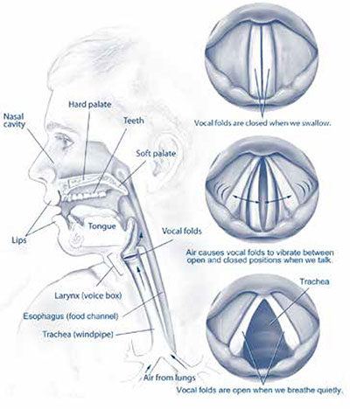

Fig. 3: Voice Organs, Vocal Cord vibrating and Vocal cord open

The vocal cords are protected by the entry of food by the epiglottis. Epiglottis is like a lid made of cartilage which moves to cover the windpipe whenever the swallows any food. The epiglottis closes the windpipe when you swallow. Without the epiglottis, liquids and solids will go into the lungs via the windpipe.(FIKES, 2020)(FIKES, 2020)

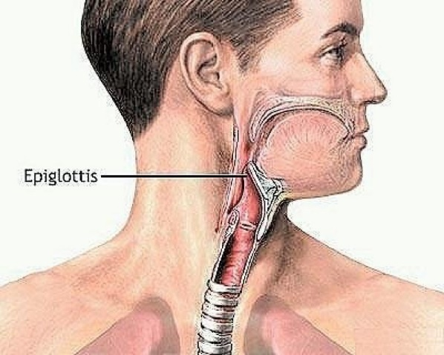

Fig. 4: Epiglotis

### 2.2.1 Larynx

The larynx is also known as called as glottis or the voice box. It is the tunnel for air to flow between [pharynx](https://api.seer.cancer.gov/rest/glossary/latest/id/5505936ce4b0c48f31d6f93b) and t[rachea](https://api.seer.cancer.gov/rest/glossary/latest/id/5502c2bce4b0c48f31d650bb), as shown in the picture below.

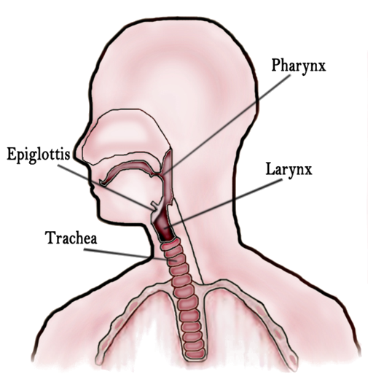

Fig. 5: Larynx

(NCI, 2020)The larynx is located towards the front of the [neck](http://emedicine.medscape.com/article/1968303-overview), below pharynx and above the trachea, Its primary objective is to prevent food from entering the lower airway. It does this by sealing the lower airway based on specific stimulation. It causes the respiration to stop temporarily. Hence it is also preventing the entry of solid or liquid food or foreign matter into the lungs. The larynx also helps in controlling breathing, coughing, phonation.

The larynx has three parts. They are sublarynx, larynx, and supralarynx. The larynx has nine connected cartilages. They are cricoid, thyroid, epiglottis, arytenoids, corniculate, cuneiform and some muscles. The cartilages are connected by ligaments and muscles. The larynx is essential for generating [speech](https://api.seer.cancer.gov/rest/glossary/latest/id/55983c3ee4b084b72ee001bd). The [epiglottis](https://api.seer.cancer.gov/rest/glossary/latest/id/55a9943ee4b05cd0cddc6bb9) has no role in sound creation. It seals the larynx when liquid or solid food gets swallowed. The hyoid bone helps with laryngeal motion. (Vashishta, 2020)

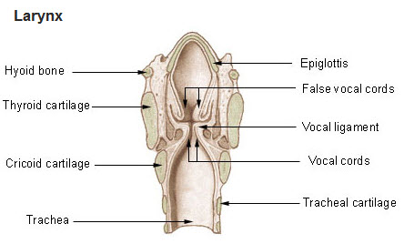

Fig. 6: Larynx Anatomy

### 2.2.2 Vocal Folds/Vocal Cords

The vocal cords are made up of thin bands of delicate muscle. They are covered by mucous membrane. They start from the front to the back of the larynx. They are attached to cartilages.(Thomas, 2020)

The vocal cords by a pair of nerves called the recurrent laryngeal nerves. The nerves control the space between the vocal cords. When is person is not speaking and is breathing, the cords are open wide. While the person is speaking the space between the cords varies to create voice. They close up during swallowing. They look like a shiny pale white plate-like structures. Arranged to form a V. Below the vocal cords is the trachea which leads to the lungs.(UNMC, 2020c)

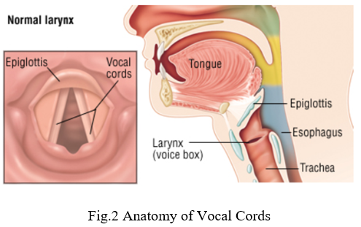

Fig. 7: Larynx and Vocal Cords

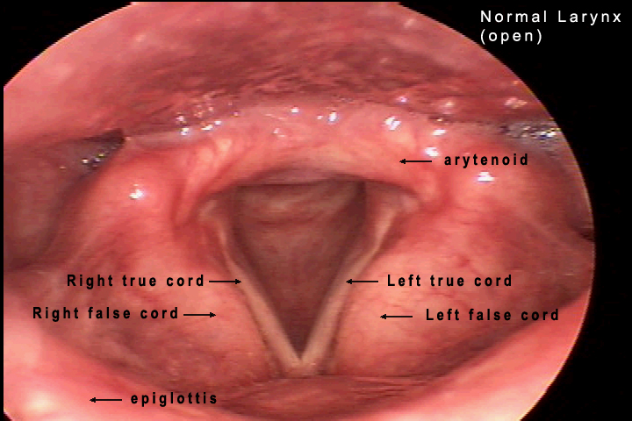

Fig. 8: Vocal Cord Opened

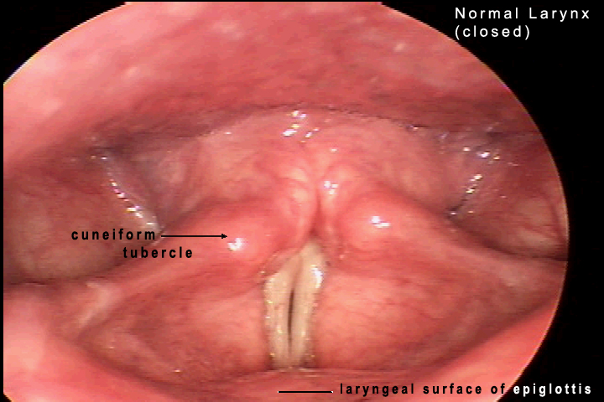

Fig. 9: Vocal Cord CLosed

## 2.2 Vocal Disorders

Vocal cord issues symptoms are hoarseness in the voice. Causes of Vocal cord injury could be yelling or smoking, clearing the throat too often, singing too high, talking for too long. These causes strain on the larynx, which then leads to an overgrowth of tissue on the vocal folds. (Thomas, 2020)

The issues could be a vocal cord cyst, polyp, nodule or ulcerated area. These cause the hoarseness in the voice. Other causes of vocal fold issues are infections which could lead to laryngitis and swelling of the folds. Inhalation of chemical pollutants in the air, reflux esophagitis, injury to the nerves that control the vocal folds. Injury due to throat or neck surgery. Vocal cord papillomas, or tumorous growths. Inflammation of the vocal folds happens in acute or chronic laryngitis. Vocal cord cancer is almost always associated with smoking.

When one or both of the vocal cords are affected, vocal disturbances are to be expected. A swelling caused by a cyst, polyp, the nodule can induce disturbances in the sound while speaking or singing (Schrotter 1893). A change in weight, width, thickness, length, width, thickness, etc., i.e. any asymmetry in the vocal cords will have an impact on the quality of one's voice. (Arnold, 1958). These changes can be considered as primary disorders of the vocal cords. They are considered secondary if the cause for the change is a disease.(Thomas, 2020)

Neoplasms or pseudotumors are considered primary disorders of the vocal cords. Benign tumours in the vocal cords are not commonly observed. A tumour is an abnormal growth of tissue. Common benign irregularities involving the vocal cords, including vocal cord nodules, polyps, cysts and hyperplastic changes (Jones et a!. 1984) are pseudotumors.(Foundation, 2020)

Vocal cord lesions are a group of abnormal growths (lesions) often benign, inside or on the vocal cord. Vocal cord nodules and cyst are the most commonly reported issues with voice.

(Chopra and Kapoor, 1997)Benign glottic lesions are quite common. When left unattended, it may enlarge enough to block the airway sufficiently, thereby are a threat to the life of the patient. In less extreme cases produce hoarseness of voice. Vocal folds are prone to develop irregularities due to overuse, smoking, overconsumption of alcohol, dust and fumes and pollution. Persons using voice extensively in their profession and homemakers and children are susceptible to benign glottic lesions.

The study by M. Stuart Strong (1971 ) found vocal nodules and polyps to be the most common irregularities. Below were the results from the study

|  |  |
| --- | --- |
| **Type of Lesion** | **Percentage of patients** |
| Vocal Nodule | 33.33 |
| Vocal Cyst | 17.33 |
| Vocal polyp | 16 |
| Laryngitis | 13.33 |
| Leukoplakia | 6.66 |
| Reinke's oedema | 5.33 |
| Haematoma | 4 |
| Papilloma | 4 |
| Pachyderma laryngis | 1.33 |
| Laryngeal web | 1.33 |

Fig. 10: Observed Occurrances

The most common irregularities of the vocal folds are:

### 2.5.1 Laryngitis

Inflammation of the vocal cords is called Laryngitis. The Inflammation causes hoarseness in the voice or makes the voice raspy.(Medicine, 2020b)

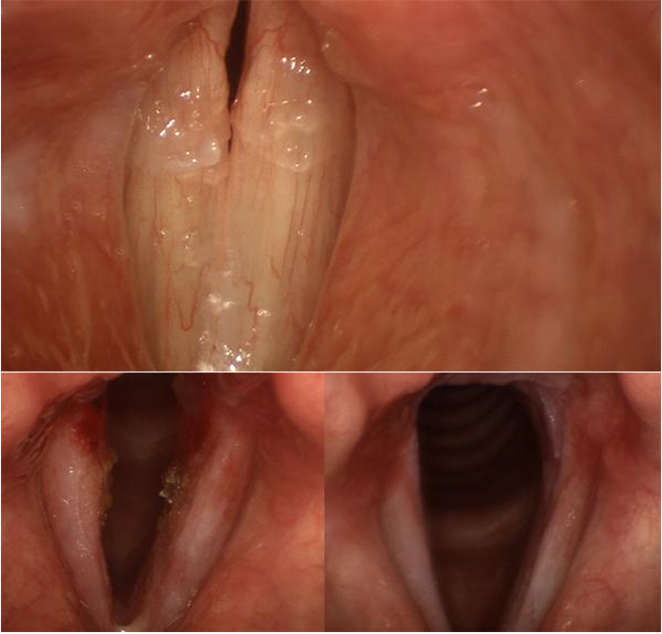

Fig. 11: Vocal Cord with Laryngitis

### 2.5.2 Vocal Fold Nodules

Vocal nodules are noncancerous a thickening and hardening of the skin vocal cords. They are caused by vocal abuse. Vocal nodules are common in professional singers and people using voice significantly in their profession. They typically are found pairs and located at the centre of the membranous part of the vocal fold. They are often one on each cord and face each other. The nodules occur in a part of the vocal cord which is under the most pressure when the cords come together and vibrate. Vocal nodules make the voice to be breathy, low and hoarse. These are considered calluses of vocal cord as they reduce in size or disappear when the misuse of the vocal cord by the patient stops. (UNMC, 2020b)

Many laryngologists factor in the age of the nodule when suggesting possible treatment.

1. Recently created nodules most often go away on their own. Therefore, voice therapy is suggested. Typically, surgery is not required.
2. Old or hard nodules must be surgically removed.

Children, especially young boys and young adult females are susceptible to Vocal fold nodules. So are people with a loud voice. There is a correlation between how extroverted a person is to the probability of occurrence of vocal fold nodule.

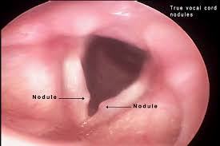

Fig. 12: Vocal Cord Nodule

### 2.5.3 Vocal Fold Polyp

A vocal fold polyp is similar to vocal cord nodules until you look under a microscope. They usually occur on either side of the vocal cord. Polyps are more reddish than their surroundings. This is because of the extra blood vessel supply in the polyp. A vocal fold polyp has varied shapes and sizes. Vocal cord polyps can cause a number of voice irregularities.

A vocal polyp is like a blister. It is soft and non-malignant growth. It may include a blood clot inside the blister. Vocal cord polyp usually resolves over time. When Voice polyps are present, it makes the patient's voice to below, breathy, and hoarse.(Gardner, 2020)(Dhillon, 2020)

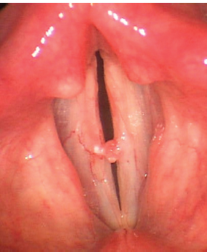

Fig. 13: Vocal Cord Nodule

### 2.5.4 Vocal Cord Paralysis

Paralysis is the loss of muscle function in part of your body. Vocal cord Paralysis is when either one of the vocal cords or both the vocal cords do not open or close properly. In the case where one vocal cord is paralyzed, the voice becomes feeble. Solids or liquids can enter the trachea and then the lungs. It causes the patient to have trouble swallowing. The patient may choke or cough when they swallow. Patients with both vocal cords paralyzed may have trouble breathing.

Vocal cord paralysis is caused by:

* Neck injury.
* Complications during a surgery
* Tumour or a Stroke
* Lung cancer
* Neurological disorders
* Viral infection

Treatment in extreme cases will need surgery, followed by voice therapy. In some cases, no treatment required. Patient recovers by themself.(LLC, 2020)

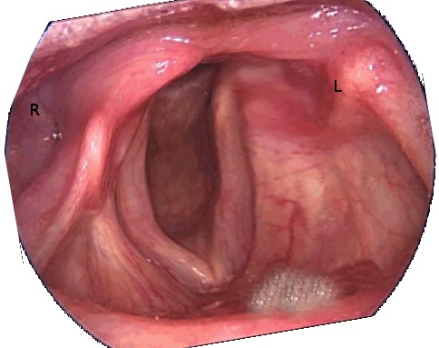

Fig. 14: Vocal Cord Paralysis

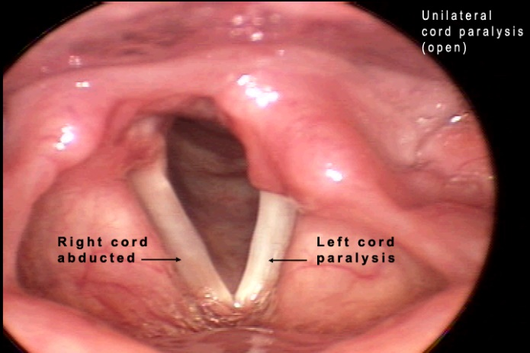

Fig. 15: Vocal Cord Paralysis

### 2.5.5 Laryngeal Papillomatosis

A papilloma is a soft non-malignant epithelial tumour. It grows outwardly and looks nipple-like or like a mulberry fruit. Laryngeal Papillomatosis occurs anywhere in the larynx. Often, they start on the vocal folds. They hinder the vocal cords from meeting at the centre and reducing the wave motion. (UNMC, 2020a)

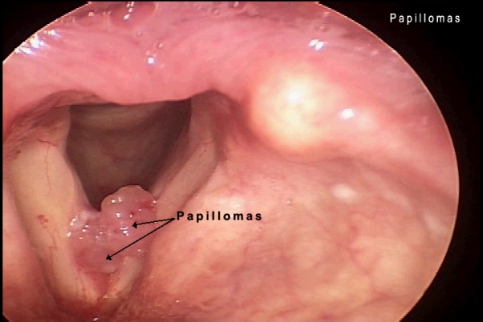

Fig. 16: Laryngeal Papilloma

Causes and symptoms of Vocal Cord Disorder, most often to cause of the vocal cord cyst is misuse or abuse of the vocal cords. Abuse like smoking, exposure to pollution, overuse of voice to yell, cough, sing and talk. Symptoms include changes in your familiar voice. The voice becomes hoarse or raspy.(Dhillon, 2020)

Diagnosis and Treatment, one should consult a voice specialist or ENT when there is hoarseness or change in voice for more than four weeks. It is essential to see a voice specialist or ENT for a full examination of the vocal folds if symptoms do not resolve within four weeks. The voice specialist may examine the vocal cords with a called a laryngoscope.(Dhillon, 2020)

### 2.5.6 Vocal cord cyst

Identification of a vocal cord cyst is the objective of this study. This disorder of the vocal cord is discussed in detail in section 2.6

## 2.3 Vocal Cord Cyst

Identification of a vocal cord cyst is the objective of this study. A vocal fold cyst is a solid or semi-solid mass of mucus surrounded by a sac. The vocal cord cyst may be located near the surface of the vocal fold or the ligament of the vocal cord.

Vocal cord cysts can develop in several ways:

1. Before birth, while a baby’s vocal cords are developing
2. From abuse of the voice like yelling and frequent use
3. Mucous becomes trapped in the glands in the voice box (similar to a pimple)(NIDCD, 2020)

Vocal Cord Cysts are usually created by blockage of a small mucus gland. The blockage occurs on the surface of the vocal fold. These usually require microsurgery. The impact on a cyst on the voice of the patient depends on the size and location of the cyst. The impact is similar to a polyp or nodule. Vocal cord cyst causes hoarseness in the voice. Surgery is not required in most cases unless the vocal cord cyst dramatically impacts the patient's voice. Post the surgery voice therapy has suggested preventing recurrence of the lesion.(Medicine, 2020a)

A vocal cord cyst is a spherical or oval structure. The cyst is non-malignant structure, located below the surface of the vocal cord. It is uncommon to see on both vocal cords (folds) at the same time.  (AARON, 2020)

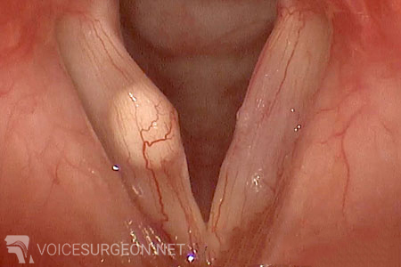

Fig. 17: Vocal Cord Cyst

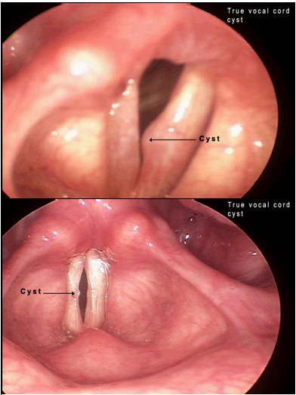

Fig. 18: Vocal Cord Cyst

Causes:(UNMC, 2020a)

* In utero, while a baby’s vocal cords are developing
* Overuse, Straining, yelling and frequent singing.
* Mucous becomes trapped in the glands in the vocal cord

Treatment of Vocal cord cysts is by surgical excision. Vocal cord cyst usually does not subside by voice therapy. However, the need for surgery can be delayed. If during the surgery the vocal cord cyst is completely removed, the chances of a full recovery are good. However, voice therapy is needed post-surgery. There is a possibility of scarring. It may cause voice problems.

In some cases, if the cyst may rupture, which can cause scarring and cause persistent voice problems. The surgery is called Phonomicrosurgery.(AARON, 2020; CHOP, 2020)

## 

## 2.4 Diagnosis and Treatment of Vocal Disorder

### 2.4.1 Indirect Laryngoscopy

Indirect Laryngoscopy utilizes a little mirror held at the rear of your throat. The medical care provider focuses light on the mirror to see the throat region. It is a straightforward strategy. More often than not, it tends to be done in the doctor’s office while the patient is awake. A medication to numb the rear of your throat might be utilized.(Dinesh, 2020)

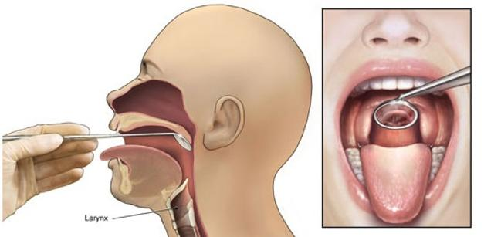

Fig. 19: Indirect Laryngoscopy

### 2.4.2 Direct Laryngoscopy

In a direct laryngoscopy, the specialist can utilize various kinds of laryngoscopes, which are long, slim instruments with a light and a focal point or little camcorder on end. The laryngoscope is placed in through your nose or mouth and down your nose.

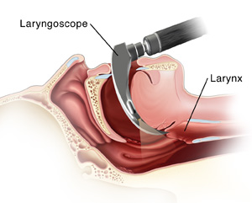

Fig. 20: Direct Laryngoscopy

### 2.4.3 Flexible Fiberoptic Laryngoscopy

Flexible fiberoptic laryngoscopy is the most well-known assessment used to see the throat and its encompassing structures. Perform endoscopically; it is performed to picture irregularities, biopsy tissue, or eliminate little developments, for example, cyst, from the surroundings. The flexible fiberoptic laryngoscopy empowers the specialist to see the accompanying regions: nasopharynx (back of the nose), oropharynx (back of the mouth), larynx (voice box) and hypopharynx (access to the gulping entry). (Leonardo, 2020)

One preferred position of this kind of Laryngoscopy is that the versatile camera can be absolutely controlled, permitting the specialist a full perspective on the movement of the vocal cords. Another is that since the endoscope utilized in this system is produced using slender, adaptable fiberoptic link, the patient encounters just insignificant inconvenience and requires no recovery time. Since the system is frequently acted in the specialist's office, it is helpful and straightforward to plan.

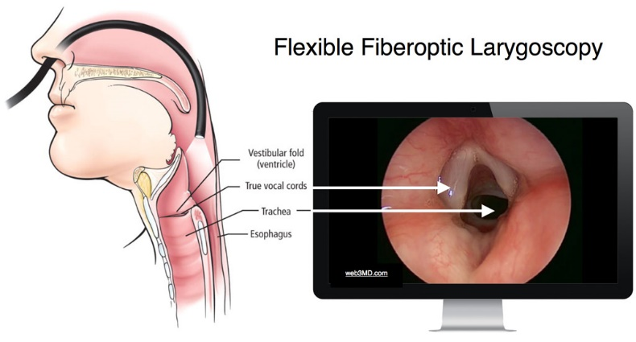

Fig. 21: Flexible Fiberoptic Laryngoscopy

Fig. 22: Laryngoscopy procedure

The flexible fiberoptic laryngoscopy might be performed to analyse any of the below conditions(Ramesh, 2020):

* Dysphagia
* Vocal polyps and nodules
* Laryngeal granuloma
* Spasmodic dysphonia
* Cancer of the larynx
* Other problems with the voice box or throat

### 2.4.4 The Flexible Fiberoptic Laryngoscopy Procedure

To begin with, the specialist applies an effective sedative to the rear of the throat to facilitate any uneasiness. The flexible fiberoptic laryngoscope is embedded into the patient's nose, moved into the throat until it is close to the region of interest. During the procedure, the patient can breathe naturally. (.viveromd, 2020)

The patient remains alert, giving the specialist a more clear perspective on the vocal ropes. During the Laryngoscopy, the patient will be asked to make moderate long vowel sounds, for example, an 'ee' or 'ah', so the movement of the vocal cords can be watched. The specialist may take photos with the camera at the tip of the flexible fiberoptic laryngoscope for further investigation at a later time. Sometimes, the specialist may take a tissue biopsy through the endoscope for analysis.

The flexible fiberoptic laryngoscopy is a generally painless, lasting for no more than 30 minutes. After the system, the patient may have a feeling that the throat is swollen and may encounter a severe persistent flavour; however, these side effects are brief. When the procedure is finished, patients can quickly get back regular life.(.viveromd, 2020)

### 2.4.5 Phonomicrosurgery

Phonomicrosurgery is a procedure designed to remove lesions such as vocal fold nodules, polyps, or cysts via the mouth to improve the quality of one’s voice. The procedure is performed under general anaesthesia in the operating room. It involves the placement of a metal tube through the mouth to push the tongue out of the way. The vocal cords are then examined under high magnification using a microscope to determine the type of lesion present.

An infusion of saline (saltwater) may be used to demonstrate areas of scarring and allow for maximal preservation of the gel-like layer (superficial lamina propria) of the vocal fold. A small incision is performed on the vocal fold to dissect the area of concern away from the regular underlying vocal fold.

There are no incisions made on the neck. The objective is to maximally preserve all common areas of the vocal fold to achieve the best vocal outcome. A laser, such as the KTP green light laser, may be used to treat any associated blood vessels or other pathology on the vocal fold at the time of the procedure.

Patients can generally go home the same day of the surgery. The patient is usually kept on strict voice rest (e.g. no speaking, whispering, or other kinds of sound production) following the procedure for a period ranging from one to three weeks depending on the complexity of the procedure performed.(StudFile, 2020)

Fig. 23: Mucosal cordotomy with sickle knife.

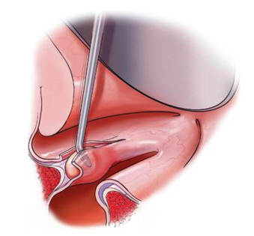

Fig. 24: Dissection between the epithelial cover and the cyst

Fig. 25: Dissection of plane deep to the vocal fold cyst, adjacent to the vocal ligament

Fig. 26: Dissection of plane deep to the vocal fold cyst, adjacent to the vocal ligament

Fig. 27: Redraping of microflap

## 2.5 Object Detection in recent years and YOLO Algorithm

Object detection is a process related to computer vision and image processing. Object detection deals with finding objects of a particular ` type in digital images or videos. The last 10 years, there has been significant enhancements in the field of object detection algorithms. Lately, convolutional neural network (CNN) are heavily used to build deep learning models. These model built using CNN outperform previous algorithms. A feature is extracted from every convolution kernel in model. Also, R-FCN utilizes position-sensitive score guides to additionally enhance object discovery capacity. YOLO and SSD acquire great situating exactness with quicker speed. With advancement of neural networks, increasingly more optimal arrangement networks are inserted in object location models. <Add more papers>

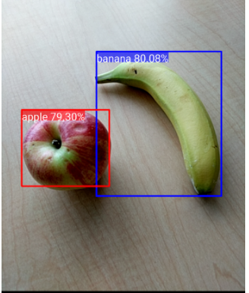

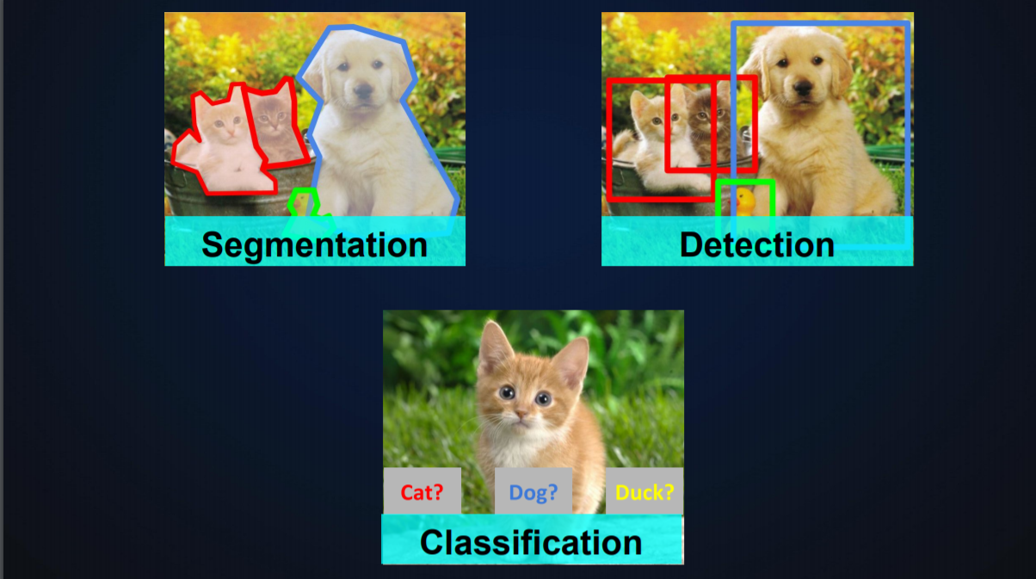

### 2.5.1 History of object detection

2.8.1 R-CNN

~~R-CNN is an object detection algorithm. It uses a sliding window approach. When using this method you just go over the whole image with different sized rectangles and look at those smaller images in a brute-force-method. The problem is you will have a giant number of smaller images to look at.~~

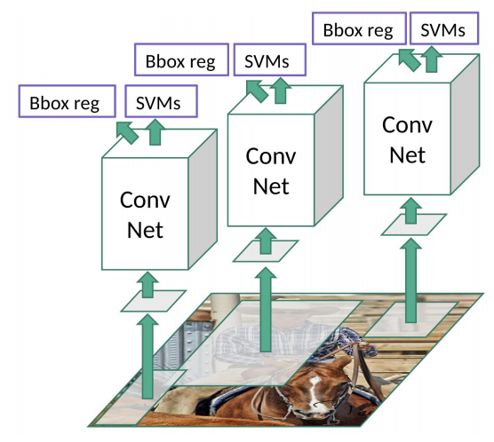

### 2.8.2 YOLO – You Only Look Once

YOLO which stands for You Only Look Once is a deep learning network for object detection. If you pass an image with of a shoal of fish to the network, it will create a bounding box around each individual fish and label it. YOLO is much faster that R-CNN (45 frames per second) and easier to optimize that R-CNN. YOLO uses only one neural network.

This research focuses on developing vocal cord cyst detection using YOLO v3. YOLO is an intelligent CNN model for object detection. They help with fast object detection. It enables real-time object detection. YOLO is a single CNN network. It splits the image into grids. Each grid predicts object detection and creates bounding box. These bounding boxes are weighted. We will then have number of candidate bounding boxes with is later consolidated.

The below figure shows the architecture of YOLO model.

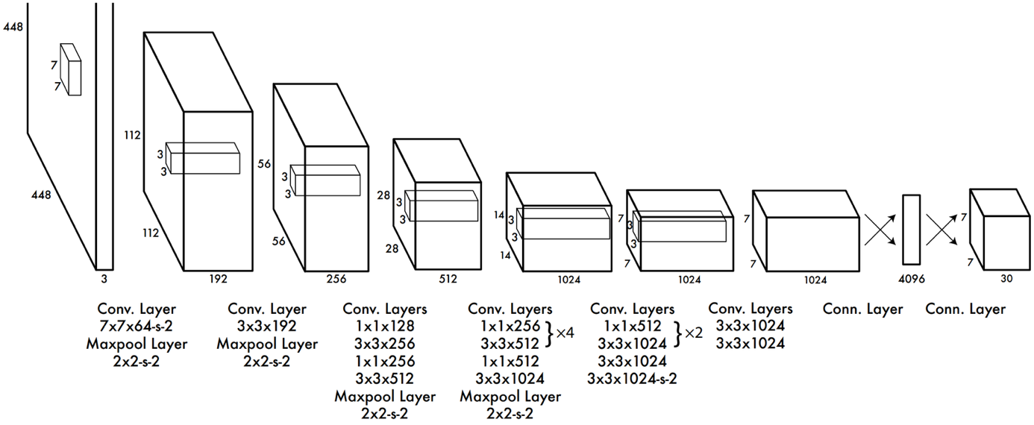

Fig. 28:YOLO Architecture (online, 2020)

### 2.8.2 History of YOLO Algorithm

**YOLO Version 1:** YOLO version 1 was release in 2015. It made use of a limited Darknet framework. The dataset limited the ability of YOLO version 1. The dataset used was ImageNet-1000

**YOLO Version 2:** YOLO version 2 was released a year after version 1. It was named YOLO9000. YOLO V2 was more performant that YOLO V1 especially identifying small objects in an image with a group of similar objects. YOLO V2 used darknet-19

**YOLO Version 3:** YOLO Version 3 is not a significant upgrade over its previous version. It is built on a different version of Darknet. YOLO3 is made of 53 . It is trained on Imagenet. It significantly increased the speed of object detection but reduce the frames per second from 45 to 30.

### 2.8.3 Working of You Only Look Once Algorithm

https://www.ijeat.org/wp-content/uploads/papers/v8i3S/C11240283S19.pdf

A frame/image is extracted from a video. The YOLO algorithm is applied on the extracted image. In the below sample, the picture is divided as grids of 3x3 matrixes. We can separate the picture into any number matrices, contingent upon the size and complexity of the picture. Once the image is partitioned, each partition undergoes localization and classification of the object. The confidence level of each partition is calculated. If no object is found in the partition, then the objectness and bounding box value of the grid will be 0. If an object is found in the grid then the objectness will be 1. Anchor boxes are used to increase the accuracy of object detection which also explained below in detail.

<https://towardsdatascience.com/yolo-you-only-look-once-17f9280a47b0>

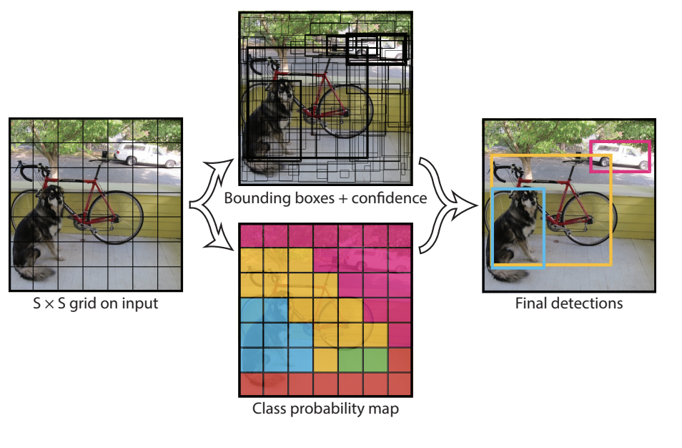

### 2.5.4 Applications of Object Detection

### 2.5.4 Applications of in HealthCare

## 2.6 Summary

Chapter 2 talked about how voice is generated, its significance to quality of life of a person. It talked in detail about the Larynx, Vocal Cord and how they help generate voice. Details of vocal cord cyst and how it is surgically removed. Chapter 2 also detailed the history of object detection and its significance in the medical field. Ending with history of YOLO and how it works

# CHAPTER 3: RESEARCH METHODOLOGY

## 3.1 Introduction

This chapter gives a brief introduction of the research methodology used. It talks about the dataset description and how it is pre-processed and transformed. It talks in detail about YOLO and how the final model is to be evaluated and the expected outcome.

## ~~3.2 Background~~

## 3.3 Dataset Description

The dataset is a collection of laryngoscopy videos. The videos are segregated based on existence of vocal cord cyst. Each video is between 60 seconds and 150 seconds long. The videos are taken by inserting a flexible and small telescope at the end of a cable, which goes up your nose and down into your throat. The videos are anonymized. i.e. there is not user identifiable data corresponding to the videos. Also gender and age is not specified.

The dataset videos have a resolution of 496 x 240. The frame rate or frames per second is 30. Data rate is 3.65 Mbits per second. In dataset videos the vocal cords are clearly visible for most part of the video. The patient is asked to make different sounds which causes the vocal cords to open, close and vibrate.

## 3.4 Data Pre-processing and Transformation

As part of data pre-processing I will take frames from the video at regular intervals. These frames will be stored as image files. These image files will need to be labelled. To label the images, image labeling software is installed to annotate such images. Labelbox is a good tool that can be used to manually label the cyst in the images we extracted from the laryngology videos (labelbox, 2020). I will also label the complete vocal cord to I can also detect the vocal cord and focus the attention of the model in the vocal cord area only. This will make the model build much faster.

Once labelled the images can then be used to train the yolo model. Several cleaning and data pre-processing techniques will be used in this study which is mentioned below:

1. **Load laryngoscopy videos to a directory**

I will download the videos/dataset to a directory on the machine where the model will be built. 2 sub-folders will be created to indicate if the video is of a vocal cord with cyst or not.

1. **Extract images from video**

Using python, I will process one video at a time and extract frames at regular intervals. Video is basically a collection of images ordered in a way that it appears to be a continuous scene. I will generate 300-400 images per video.

1. **Extract Vocal Cords from video**

Since I am focusing on vocal cord cyst which at localized to the vocal cords only, I have to narrow down the search to the vocal cord section only. This will need labelling of the vocal cord and then creating a model to detect vocal cord and extract the vocal cord section of the image. I will then store the vocal cord images in the file system. The vocal cords with cyst will be stored in a separate folder

1. **Labelling Vocal Cord Cyst**

Darknet needs a text file for every image. This file will have a line for each known location of the object in the image. Each line looks like this:

<object-type> <x-coordinate> <y-coordinate > <width> <height>

I will manually give labels to a few of the images and train the model on them

## 3.5 Models

Object detection is a technology related to image processing. For example, identifying a cat in an image. YOLO is an object detection algorithm. It is fast enough that it can detect objects in real time. Diseases of the larynx are diagnosed by a specialist. This specialist is called a laryngologist. The laryngologist performs a physical examination which includes a scope. Scope is a flexible pipe with a light and camera at the end. This helps visualize the larynx and throat. The scope is inserted deep into the patients nose until it the vocal cords are visible. This is called Laryngoscopy.

<https://www.deeplearningbook.org/>

This research experiments with Transfer Learning. Transfer Learning is a technique where knowledge (weights) from previously trained models are re-purposed to the current problem to achieve better results. These previously trained models are called Pre-trained models. Pre-Trained models are models that have been trained using available public dataset.

Transfer learning tends to give good results if the base task and the target task are similar in nature.

There are multiple Pretrained networks available. Each have different characteristics. One can understand the characteristics of these networks and choose which are that are important to solve a given machine learning problem. Network accuracy, size and speed are some of the important characteristics. Choosing a network depends on which of these characteristic matters more. It is often a trade-off between these characteristics.

Figure<> lists some of the pre-trained models

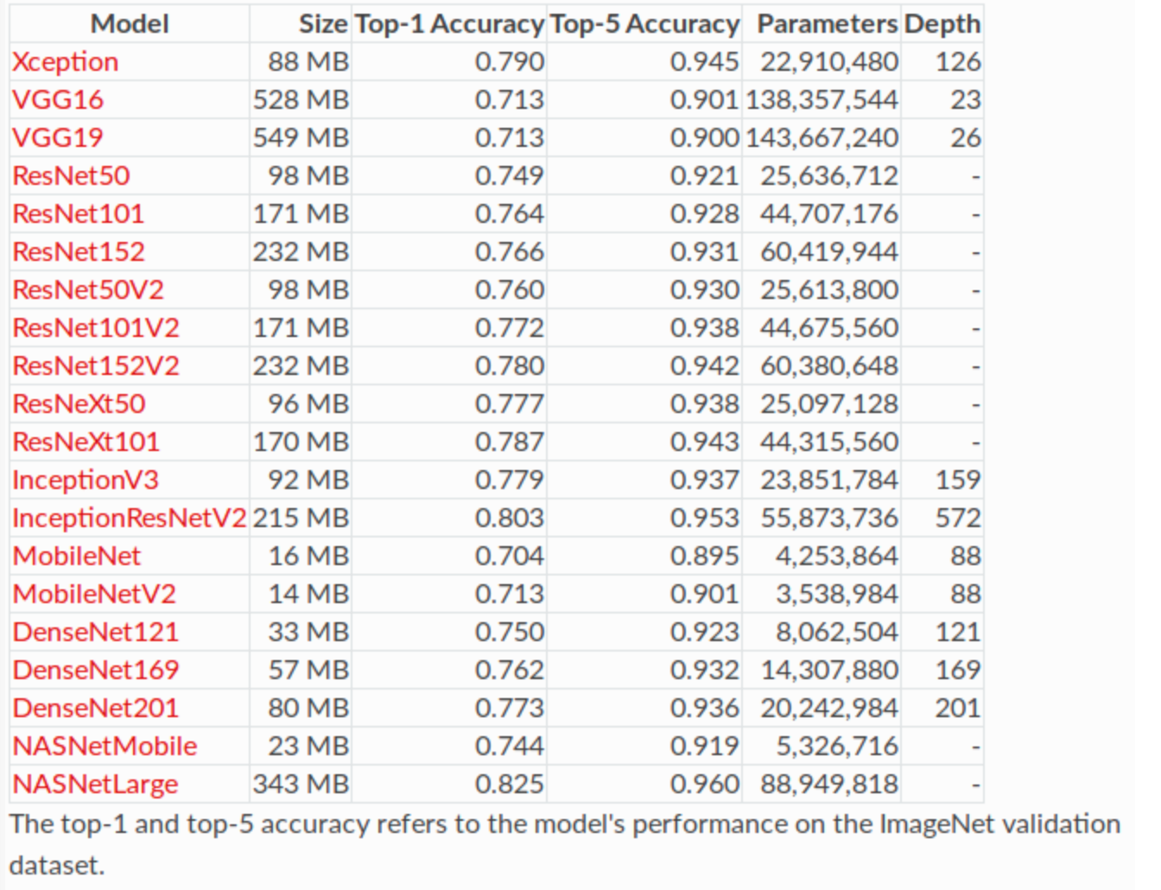

Transfer learning is used in this research as I use darknet 53. The <> weights were experimented with. **DarkNet-53** is a convolutional neural network. It has 53 layers. DarkNet-53 is often used as the base for YOLO workflows and object detection. Figure<> shows the structure of Darnet53 convolutional network.

<https://www.researchgate.net/figure/Structure-of-the-Darknet53-convolutional-network_fig4_338121987>

In this research I will be using close to 200 laryngoscopy videos with no cyst and 50+ videos laryngoscopy videos of patients suffering from vocal cord cyst. Each video is around 90 seconds each.

Object detection involves identifying one or more objects in an image. Once identified the object is identified it will can be classified. Object detection is a computer vision task. It involves locating and drawing a bounding box around a detected object in an image. Post that the object is classification to predict the correct type of object that was detected.

The “You Only Look Once,” or YOLO models are CNN based deep learning models. They help with fast object detection. YOLO is a single CNN network. It splits the image into grids. Each grid predicts object detection and creates bounding box. We will then have number of candidate bounding boxes with is later consolidated.

There are multiple implementations of YOLO. Darknet is one of the implementation of YOLO. Darknet is implemented in C and CUDA technology. It is very fast as it uses GPU for computation thus enabling real-time object detection. Darknet needs to be configured to run on GPU to significantly reduce the time needed to build a model. Figure<> shows how YOLO network is built on top of Darknet53. The Darknet-53 network in YOLOv3 uses multiple 1 × 1 and 3 × 3 convolutional layers. They connect local feature interactions. Their function is similar to the global connection of the complete features. The feature extraction network has 53 convolutional layers, and its structure is shown at the top in Figure <>. In Darknet-53, 1 × 1 and 3 × 3 alternating convolution kernels are used, and after each layer of convolution, the BN layer is used for normalization. The Leaky Relu function is used as the activation function, the pooling layer is discarded, and the step size of the convolution kernel is enlarged to reduce the size of the feature map. As the network structure is deeper, its ability to extract features is also enhanced. The function of the sampling layer is to generate the small-size images by interpolation of small-size feature maps and other methods. When short connections are set up between some layers to connect low-level features with high-level ones, the fine-grained information of high-level abstract features is enhanced, and they can be used for class prediction and bounding box regression.

This research focuses on developing vocal cord cyst detection using YOLO v3. YOLO is an intelligent CNN model for object detection. They help with fast object detection. It enables real-time object detection. The YOLOv3 algorithm is an improvement on previous version of YOLO which is YOLOv1 and YOLOv2. Compared to the previous version it has high detection accuracy, accurate positioning, and is faster. Especially when the multi-scale prediction methods are introduced, it can achieve the detection of small targets and has good robustness to environmental scenes, therefore, it has become a current research hotspot. The network structure of the YOLOv3 algorithm is shown in Figure 2. The residual network is mainly used to upgrade the feature extraction network, and the basic backbone network is Darknet-53 to extract features and obtain deeper feature information.YOLO is a single CNN network. It splits the image into grids. Each grid predicts object detection and creates bounding box. These bounding boxes are weighted. We will then have number of candidate bounding boxes with is later consolidated.

The below figure shows the architecture of YOLO model.



Fig. 28:YOLO Architecture (online, 2020)

## 3.6 Evaluation Metrics

The mean average precision (mAP) is a metric used to measure the performance of object detection models. The Mean Average Precision (MAP) is the arithmetic mean of the average precision values for an information retrieval system over a set of n query topics.

Figure<> shows the mAP equation

<https://trec.nist.gov/pubs/trec14/appendices/CE.MEASURES05.pdf>

Write theory about all metrics in this

*calculation mAP (mean average precision)...*

*Detection layer: 16 - type = 28*

*Detection layer: 23 - type = 28*

*144*

*detections_count = 281, unique_truth_count = 193*

*class_id = 0, name = vocalcord, ap = 81.86% (TP = 43, FP = 9)*

*class_id = 1, name = cyst, ap = 96.54% (TP = 134, FP = 3)*

*for conf_thresh = 0.25, precision = 0.94, recall = 0.92, F1-score = 0.93*

*for conf_thresh = 0.25, TP = 177, FP = 12, FN = 16, average IoU = 73.65 %*

*IoU threshold = 50 %, used Area-Under-Curve for each unique Recall*

*mean average precision (mAP@0.50) = 0.891972, or 89.20 %*

*Total Detection Time: 1 Seconds*

*There are 4 outcomes of a model on a given data*

*(FP) False positive which means Prediction is positive and incorrect*

*(FN) False negative which means Prediction is negative and incorrect*

*(TP) True positive which means Prediction is positive and correct*

*(TN) True negative which means Prediction is negative and correct*

(Ghoneim, 2020)

### **3.6.1 Accuracy**

It’s the ratio of the correctly labelled dataset items to the whole pool of items.

Accuracy = (TP+TN)/(TP+FP+FN+TN)

numerator: all correctly predicted outcomes

denominator: all outcomes

### **3.6.2 Precision**

Precision is the ratio of the correctly positive labelled dataset items to all positive labelled dataset items.

numerator: positive labelled correctly predicted outcomes.  
denominator: all ­­positive labelled outcomes

<https://tamucc-ir.tdl.org/bitstream/handle/1969.6/5637/Liu%2C%20Guangrui%20thesis.pdf?sequence=1&isAllowed=y>

### **3.6.3 Recall**

Recall is the ratio of the correctly positive labelled dataset items to all positives in the dataset.  
Recall = TP/(TP+FN)  
numerator: positive labelled correctly predicted outcomes.  
denominator: all positives in dataset

### **3.6.4 Specificity**

Specificity is the correctly negative labelled by the program to all negatives in the dataset.

Specificity = TN/(TN+FP)

numerator: negative labelled positives in dataset.

denominator: all negatives in dataset

## 3.7 Expected Outcomes

From this research, I expect the YOLO model to detect and highlight a vocal cord cyst in a vocal cord if it exists. Also, I expect the model to display the confidence which with the cyst was detected. The Figure 4 is how I expect to output to be.

Fig. 29: Expected Outcome

## 3.8 Requirements

Below are the resources needed for this research work. YOLO performs much better on a GPU compared to a CPU:

1. GPU Nvidia based graphics card with [CUDA cores](https://www.lifewire.com/what-is-nvidia-cuda-834095).
2. Multi core CPU. Minimum of 2 cores.
3. Linux operating system. Preferably Ubuntu
4. Darknet library
5. OpenCV library
6. Python 3.7+
7. Anaconda
8. Laryngoscopy dataset
9. LabelBox library

## 3.9 Summary

In Chapter 3 we talked about the research methodology used and the dataset description. We then talked about how it is pre-processed and transformed. We then talked about YOLO and how the final model is to be evaluated and the expected outcome.

# CHAPTER 4: IMPLEMENTATION

## 4.1 Introduction:

This chapter provides details of how the dataset is collected, how it is transformed, labelled and used. It mentions the model architecture and training parameters. It then shows visual representation of the data and finishing with the summary of this chapter.

## 4.2 Dataset Description:

As mentioned previously the dataset is a collection of laryngoscopy videos. The dataset was borrowed from Cognizn Software Solution. Each video is of a patient suffering from a vocal disorder. A subset of the videos is of patients with Vocal Cord Cyst. Each video is between 60 seconds and 150 seconds long. The dataset videos have a resolution of 496 x 240. The frame rate or frames per second is 30. Data rate is 3.65 Mbits per second.

## 4.3 Dataset Preparation and Visualisation

The dataset has a mix of videos of patients with vocal cord cyst and those with other ailments. The research segregated the videos of patients with vocal cord cyst. The segregated the videos of patients with vocal cord cyst were validated from a medical expert to ascertain that they are infact of vocal cords with cyst. Ideal image size for YOLO is 416x416, therefore I convert all the videos to 416x416 size using a python program. For object detection using YOLOv3 we need to extract frames from the dataset of videos. To do this extraction of frames I use ffmpeg library. FFmpeg is the leading multimedia framework, able to decode, encode, transcode, extract frames from a video stream.

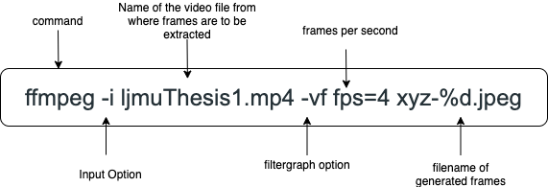

In my experiment I have set the framerate of 4 per second. i.e. ffmpeg will extract 4 images per second of the laryngoscopy video at equally spaced intervals. The generated frame images are names are same as the video file with an incrementing numeric value appended. The extension of the file is jpeg. Since I resized the video to 416x416 before extracting the frames, the extracted frames are of 416x416 size. The extraction of frame results in a big number of images per video. I then visually examine every image and retain only those when a vocal cord cyst or vocal cord is visible. The rest are deleted. Figure<> is an example of an extracted image when the vocal cord cyst or vocal cord is not clearly visible and hence is deleted from the dataset.

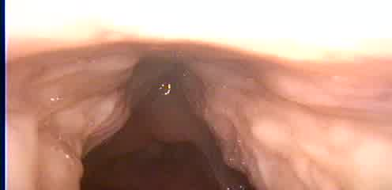

Figure<> is an example of an extracted image with vocal cord but without vocal cord cyst

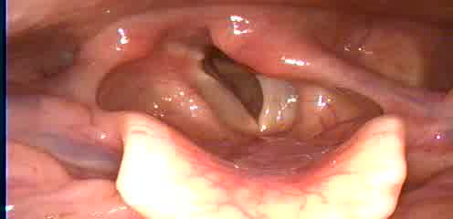

Figure <> is an example of an extracted image with vocal cord and vocal cord cyst

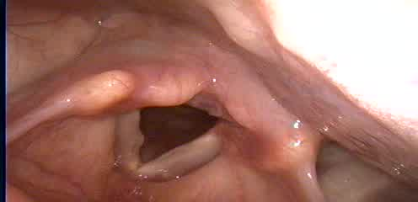

The images were then annotated with LabelImg. LabelImg is a graphical image annotation tool. Annotations are saved as XML files in PASCAL VOC format. Figure<> show the process of annotating an image with LabelImg

Figure<> shows a generated annotation file for an image. It contains the x and y axes of the bounding box of each label.

PASCAL VOC annotation format needs to be converted to an annotation format compatible with YOLO. I chose PASCAL VOC format and then converted to YOLO compatible annotation because other object detection algorithm can use the annotation I generate. YOLO compatible annotations cannot be converted to PASCAL VOC. An online tool provided by Roboflow, Inc converts PASCAL VOC to

YOLO format. YOLO format annotation is a simple txt file with space separated values. The values are from 0 to 1. Figure<> shows a YOLO format annotation



The set of annotated images need to be split into groups as test data and train data. Once segregated we need to create test.txt and train.txt. The file test.txt contains path to every annotated image in the test group. Similarly, the file train.txt contains path to every annotated image in the train group. It is important to note that the YOLO annotation txt file have the same name as the image for which it contains the annotations.

## 4.5 Model Implementation

### Details of the architecture

Specifically how many layers, size of filters

Number of trainable parameters

Config

Model Layers

|  |  |  |  |  |  |
| --- | --- | --- | --- | --- | --- |
| **Layer** | **Type** | **Filters** | **Size** | **Input** | **Output** |
| 1 | Convolutional Layer | 16 | 3 x 3/ 1 | 416 x 416 x 3 | 416 x 416 x 16 0.150 BF |
| 2 | Max Pooling |  | 2x 2/ 2 | 416 x 416 x 16 | 208 x 208 x 16 0.003 BF |
| 3 | Convolutional Layer | 32 | 3 x 3/ 1 | 208 x 208 x 16 | 208 x 208 x 32 0.399 BF |
| 4 | Max Pooling |  | 2x 2/ 2 | 208 x 208 x 32 | 104 x 104 x 32 0.001 BF |
| 5 | Convolutional Layer | 64 | 3 x 3/ 1 | 104 x 104 x 32 | 104 x 104 x 64 0.399 BF |
| 6 | Max Pooling |  | 2x 2/ 2 | 104 x 104 x 64 | 52 x 52 x 64 0.001 BF |
| 7 | Convolutional Layer | 128 | 3 x 3/ 1 | 52 x 52 x 64 | 52 x 52 x 128 0.399 BF |
| 8 | Max Pooling |  | 2x 2/ 2 | 52 x 52 x 128 | 26 x 26 x 128 0.000 BF |
| 9 | Convolutional Layer | 256 | 3 x 3/ 1 | 26 x 26 x 128 | 26 x 26 x 256 0.399 BF |
| 10 | Max Pooling |  | 2x 2/ 2 | 26 x 26 x 256 | 13 x 13 x 256 0.000 BF |
| 11 | Convolutional Layer | 512 | 3 x 3/ 1 | 13 x 13 x 256 | 13 x 13 x 512 0.399 BF |
| 12 | Max Pooling |  | 2x 2/ 1 | 13 x 13 x 512 | 13 x 13 x 512 0.000 BF |
| 13 | Convolutional Layer | 1024 | 3 x 3/ 1 | 13 x 13 x 512 | 13 x 13 x1024 1.595 BF |
| 14 | Convolutional Layer | 256 | 1 x 1/ 1 | 13 x 13 x1024 | 13 x 13 x 256 0.089 BF |
| 15 | Convolutional Layer | 512 | 3 x 3/ 1 | 13 x 13 x 256 | 13 x 13 x 512 0.399 BF |
| 16 | Convolutional Layer | 21 | 1 x 1/ 1 | 13 x 13 x 512 | 13 x 13 x 21 0.004 BF |
| 17 | YOLO |  |  |  |  |
| 18 | Route | 13 |  |  | 13 x 13 x 256 |
| 19 | Convolutional Layer | 128 | 1 x 1/ 1 | 13 x 13 x 256 | 13 x 13 x 128 0.011 BF |
| 20 | Upsample |  | 2x | 13 x 13 x 128 | 26 x 26 x 128 |
| 21 | Route | 19 8 |  |  | 26 x 26 x 384 |
| 22 | Convolutional Layer | 256 | 3 x 3/ 1 | 26 x 26 x 384 | 26 x 26 x 256 1.196 BF |
| 23 | Convolutional Layer | 21 | 1 x 1/ 1 | 26 x 26 x 256 | 26 x 26 x 21 0.007 BF |
| 24 | YOLO |  |  |  |  |

Table<>

## 4.7 Summary

This chapter showed us the visual representation of the dataset and the complexities of acquiring the dataset. It details how data was transformed, labelled and used. It mentioned the model architecture and training parameters.

# CHAPTER 5: Results and Evaluation

## 5.1 Introduction

## 

## 5.2 Model output

### 

|  |  |  |  |  |  |  |  |  |  |  |  |
| --- | --- | --- | --- | --- | --- | --- | --- | --- | --- | --- | --- |
|  | VocalCord | | | Cyst | | |  |  |  |  |  |
| Iterations | TP | FP | AP | TP | FP | AP | Precision | Recall | F1-Score | Average IOU | mAP@0.50 |
| 1000 | 24 | 14 | 53.79 | 119 | 2 | 94.45 | 0.9 | 0.74 | 0.81 | 67.1 | 0.741213 |
| 2000 | 36 | 20 | 66.38 | 134 | 3 | 96.51 | 0.88 | 0.88 | 0.88 | 67.96 | 0.814428 |
| 3000 | 40 | 13 | 75.19 | 134 | 4 | 96.42 | 0.91 | 0.9 | 0.91 | 70.18 | 0.85806 |
| 4000 | 42 | 16 | 73.55 | 135 | 1 | 96.64 | 0.91 | 0.92 | 0.91 | 71.26 | 0.850922 |
| 5000 | 42 | 11 | 75.99 | 134 | 2 | 97.08 | 0.93 | 0.91 | 0.92 | 72.83 | 0.865374 |
| 6000 | 42 | 13 | 81.81 | 135 | 4 | 96.6 | 0.91 | 0.92 | 0.91 | 71.95 | 0.892064 |
| 7000 | 43 | 12 | 85.9 | 136 | 4 | 97.22 | 0.92 | 0.93 | 0.92 | 72.69 | 0.915604 |
| 8000 | 44 | 12 | 84.12 | 135 | 3 | 97.18 | 0.92 | 0.93 | 0.93 | 73.23 | 0.906522 |

## 5.3 Summary

# CHAPTER 6: Conclusions and Recommendations

## 6.1 Introduction

## 6.2 Discussion and Conclusion

Final takeaway

## 6.3 Contributions

## 

## 6.4 Future Work

# Chapter 4 Experiments

This chapter will give a detail introduction about the datasets used. It will present the implementation of the methodology discussed in Chapter 3 followed by the analysis of each experiment result.

## 4.1 Dataset

The study proposes a dataset of Laryngoscopy videos. The dataset is transformed, labelled, trained and analysed. The study uses YOLO version 3 object detection algorithm for vocal cord cyst detection and Labelimg for manually labelling frames of the Laryngoscopy videos.

This research will reduce the time taken for Laryngoscopy procedure, assist doctors, produce consistent results and make the procedure affordable.

### 4.1.1 Gathering Dataset

Gathering the dataset was the most challenging part of this thesis. The dataset is a collection of Laryngoscopy videos. The machines used during Laryngoscopy record the video stream of scope inserted into the patients nose until it reaches the vocal cords. The company Cognizn medical expert gave

4.1 Datasets Five datasets were involved in this experiment, KITTI [10], ImageNet [5], Pascal VOC 2007/2012 [7], road sign [2], and Face Detection Dataset and Benchmark (FDDB) [15]. Detail information about datasets are given in Table I. Name Classes Number Size KITTI [10] 80 7481 6.2GB ImageNet[5] 1000 1.2 million - Pascal VOC [7] 20 21088 2.77G Road Sign [2] 2 530 35.7MB FDDB [15] 1 2845 552 MB Table I. Information of Datasets.

4.1.2

# REFERENCES

AARON, (2020) *Vocal Cord Cyst - Vocal Cord Cyst Removal Surgery - Voice Surgeon*. [online] Available at: https://voicesurgeon.net/voice-disorders/vocal-cord-cyst/ [Accessed 21 Sep. 2020].

Ramesh, (2020) *Laryngoscopy*. [online] Available at: https://www.slideshare.net/rameshparajuli14/laryngoscopy-50311513 [Accessed 21 Sep. 2020].

NCI, (2020) *Larynx & Trachea | SEER Training*. [online] Available at: https://training.seer.cancer.gov/anatomy/respiratory/passages/larynx.html [Accessed 21 Sep. 2020].

Foundation, V., (2020) *Understanding Nodules, Polyps, Cysts*. [online] Available at: https://voicefoundation.org/health-science/voice-disorders/voice-disorders/vocal-fold-nodules-polyps-cysts-and-reactive-lesions/understanding-nodules-polyps-cysts/ [Accessed 21 Sep. 2020].

CHOP, (2020) *Vocal Cord Cysts | Children’s Hospital of Philadelphia*. [online] Available at: https://www.chop.edu/conditions-diseases/vocal-cord-cysts [Accessed 21 Sep. 2020].

Chopra, H. and Kapoor, M., (1997) Study of benign glottic lesions undergoing microlaryngeal surgery. *Indian Journal of Otolaryngology and Head & Neck Surgery*, 493, pp.276–279.

Dhillon, V.K., (2020) *Vocal Cord Disorders | Johns Hopkins Medicine*. [online] Available at: https://www.hopkinsmedicine.org/health/conditions-and-diseases/vocal-cord-disorders [Accessed 21 Sep. 2020].

Dinesh, (2020) *A few hints for a good Indirect Laryngoscopy*. [online] Available at: https://www.docplexus.com/posts/a-few-hints-for-a-good-indirect-laryngoscopy [Accessed 21 Sep. 2020].

FIKES, B.J., (2020) *The flap about the epiglottis - The San Diego Union-Tribune*. [online] Available at: https://www.sandiegouniontribune.com/sdut-the-flap-about-the-epiglottis-2006sep24-story.html [Accessed 21 Sep. 2020].

Gardner, G.M., (2020) *Vocal Fold Nodules | Ento Key*. [online] Available at: https://entokey.com/vocal-fold-nodules/ [Accessed 21 Sep. 2020].

Leonardo, (2020) *Flexible Fiberoptic Laryngoscopy | Jeffrey E. Goldberg, MD*. [online] Available at: https://www.jgoldbergmd.com/flexible-fiberoptic-laryngoscopy.php [Accessed 21 Sep. 2020].

LLC, S.P., (2020) *[Figure, Unilateral vocal cord paralysis after a left parathyroidectomy. Image courtesy S Bhimji MD] - StatPearls - NCBI Bookshelf*. [online] Available at: https://www.ncbi.nlm.nih.gov/books/NBK535420/figure/article-30771.image.f1/ [Accessed 21 Sep. 2020].

Medicine, P., (2020a) *Vocal Cord Nodules | Vocal Chord Polyps | Vocal Chord Cysts*. [online] Available at: https://www.advancedent.com/conditions/throat-voice/vocal-cord-nodules/ [Accessed 21 Sep. 2020].

Medicine, W.C., (2020b) *Laryngitis | Sean Parker Institute for the Voice*. [online] Available at: https://voice.weill.cornell.edu/voice-disorders/laryngitis [Accessed 21 Sep. 2020].

NIDCD, (2020) *Taking Care of Your Voice | NIDCD*. [online] Available at: https://www.nidcd.nih.gov/health/taking-care-your-voice [Accessed 21 Sep. 2020].

StudFile, (2020) *Operative Techniques in Laryngology Rosen 2008 - Стр 12*. [online] Available at: https://studfile.net/preview/6361108/page:12/ [Accessed 21 Sep. 2020].

Thomas, L., (2020) *What are Vocal Cords?* [online] Available at: https://www.news-medical.net/health/What-are-Vocal-Cords.aspx [Accessed 21 Sep. 2020].

UNMC, (2020a) *Abnormal Laryngeal Function*. [online] Available at: https://app1.unmc.edu/medicine/heywood/laryngealdisease/Data/abnormalfunction.htm [Accessed 21 Sep. 2020].

UNMC, (2020b) *Benign Laryngeal Lesions*. [online] Available at: https://app1.unmc.edu/medicine/heywood/laryngealdisease/Data/benignlesions.htm [Accessed 21 Sep. 2020].

UNMC, (2020c) *Normal Laryngeal Function*. [online] Available at: https://app1.unmc.edu/medicine/heywood/laryngealdisease/Data/normalfunction.htm [Accessed 21 Sep. 2020].

Vashishta, R., (2020) *Larynx Anatomy: Gross Anatomy, Functional Anatomy of the Larynx, Laryngeal Tissue*. [online] Available at: https://emedicine.medscape.com/article/1949369-overview [Accessed 21 Sep. 2020].

.viveromd, (2020) *Phonomicrosurgery | Vivero MD*. [online] Available at: http://www.viveromd.com/how-we-help/phonomicrosurgery/ [Accessed 21 Sep. 2020].

v. A. Knyaz, (2020) *Pedestrian detection in video surveillance using fully convolutional YOLO neural network*. [online] Available at: https://www.spiedigitallibrary.org/conference-proceedings-of-spie/10334/1/Pedestrian-detection-in-video-surveillance-using-fully-convolutional-YOLO-neural/10.1117/12.2270326.short?SSO=1 [Accessed 6 Jul. 2020].

Alexey Bochkovskiy, (2020) *[2004.10934] YOLOv4: Optimal Speed and Accuracy of Object Detection*. [online] Available at: https://arxiv.org/abs/2004.10934 [Accessed 6 Jul. 2020].

Care, I. for Q. and E. in H., (2020) *How does the larynx work? - informedhealth.org*. [online] Available at: https://www.informedhealth.org/how-does-the-larynx-work.3294.en.html [Accessed 6 Jul. 2020].

Wiki, (2020) *Vocal cord cyst - Wikipedia*. [online] Available at: https://en.wikipedia.org/wiki/Vocal_cord_cyst [Accessed 6 Jul. 2020].

Children’s Hospital of Philadelphia, (2020) *Vocal Cord Cysts | Children’s Hospital of Philadelphia*. [online] Available at: https://www.chop.edu/conditions-diseases/vocal-cord-cysts [Accessed 6 Jul. 2020].

Cleveland Clinic, (2020) *Vocal Cord Nodules, Polyps & Cysts: Treatment & Prevention*. [online] Available at: https://my.clevelandclinic.org/health/diseases/15424-vocal-cord-lesions-nodules-polyps-and-cysts [Accessed 6 Jul. 2020].

Ghoneim, S., (2020) *Accuracy, Recall, Precision, F-Score & Specificity, which to optimize on?* [online] Available at: https://towardsdatascience.com/accuracy-recall-precision-f-score-specificity-which-to-optimize-on-867d3f11124 [Accessed 6 Jul. 2020].

H. Irem Turkmen ; M. Elif Karsligil ; Ismail Kocak, (2020) *Classification of vocal fold nodules and cysts based on vascular defects of vocal folds - IEEE Conference Publication*. [online] Available at: https://ieeexplore.ieee.org/abstract/document/6661959 [Accessed 6 Jul. 2020].

Indrajit Saha, (2020) *Machine Learning for Object Labelling - IEEE Conference Publication*. [online] Available at: https://ieeexplore.ieee.org/document/8650324 [Accessed 6 Jul. 2020].

Joseph Redmon, (2020) *YOLO9000: Better, Faster, Stronger - IEEE Conference Publication*. [online] Available at: https://ieeexplore.ieee.org/document/8100173 [Accessed 6 Jul. 2020].

labelbox, (2020) *Labelbox overview - Labelbox Docs: API Reference, Tutorials, and Integration*. [online] Available at: https://labelbox.com/docs/introduction/labelbox-intro [Accessed 6 Jul. 2020].

Matava, C., Pankiv, E., Raisbeck, S., Caldeira, M. and Alam, F., (2020) A Convolutional Neural Network for Real Time Classification, Identification, and Labelling of Vocal Cord and Tracheal Using Laryngoscopy and Bronchoscopy Video. *Journal of Medical Systems*, [online] 442, pp.1–10. Available at: https://link.springer.com/article/10.1007/s10916-019-1481-4 [Accessed 6 Jul. 2020].

Medscape, (2020) *Vocal Fold Cysts: Background, Problem, Epidemiology*. [online] Available at: https://emedicine.medscape.com/article/866019-overview#a6 [Accessed 6 Jul. 2020].

Nebraska Medical center, (2020) *Benign Laryngeal Lesions*. [online] Available at: https://app1.unmc.edu/medicine/heywood/laryngealdisease/Data/benignlesions.htm [Accessed 6 Jul. 2020].

online, (2020) *GstInference with TinyYoloV2 architecture*. [online] Available at: https://developer.ridgerun.com/wiki/index.php?title=GstInference/Supported_architectures/TinyYoloV2 [Accessed 6 Jul. 2020].

Redmon, J., Divvala, S., Girshick, R. and Farhadi, A., (n.d.) *You Only Look Once: Unified, Real-Time Object Detection*. [online] Available at: https://goo.gl/bEs6Cj. [Accessed 6 Jul. 2020].

Redmon, J. and Farhadi, A., (n.d.) *YOLOv3: An Incremental Improvement*. [online] Available at: https://pjreddie.com/yolo/.

# APPENDIX A: RESEARCH PLAN



# APPENDIX B: RESEARCH PROPOSAL

An Experimental Study to Detect the vocal cyst using YOLO

By

Mohammed Mujeeb Kaladgi

Thesis proposal

Master of Science in Machine Learning & AI

Liverpool John Moores University (LJMU)

July 2020

# APPENDIX C: ETHICS FORMS

